Amenities

• People in general want as many amenities as their employer will offer so long as it doesn’t cut into their own compensation/benefits

• Many people surveyed are in favor of having either an in-house fitness center and/or local fitness center vouchers. Opinions vary as to whether or not the people surveyed will actually use such an in-house facility.

• Over half of people surveyed (58.5%) are in favor of a cafeteria and a larger margin of people surveyed (62.2%) are in favor of having a plenty of nearby eating areas.

• Many cite convenience/ease of access to food as an important factor. Some seem content with bringing their own lunches. Others commented that they hope to have healthy and cheap food options if there is a cafeteria. (commentary- Although healthy foods would likely be available in a cafeteria, providing food at a lower cost than local restaurants/eateries is unlikely. Usually corporations bring in outside contractors that arrange the cafeteria food sourcing/management/etc. Those companies operate for profit and usually aren’t particularly cheap.)

• Over half of people surveyed were in favor of quiet/relaxation area, break room, and attached outdoor greenspace. This is consistent with the idea that people are in favor of as many amenities as possible so long as it doesn’t change their own compensation/benefits. Most cite that such areas can help to reduce workplace stress.

Departmental Dependencies

In my department…

**I benefit most from working independently (78).**

* 11.54% - Disagree
* 26.92% - Neutral
* 42.31% - Agree
* 19.23% - Strongly Agree

**I benefit most from collaborative work (81).**

* 2.47% - Strongly Disagree
* 4.94% - Disagree
* 24.69% - Neutral
* 48.15% - Agree
* 19.75% - Strongly Agree

**I value my privacy (77).**

* 5.19% - Disagree
* 12.99% - Neutral
* 55.84% - Agree
* 25.97% - Strongly Agree

**It’s easy to communicate with my coworkers within my workspace (80).**

* 3.75% - Strongly Disagree
* 7.50% - Disagree
* 20% - Neutral
* 33.75% - Agree
* 35% - Strongly Agree

Rely on which departments, if any, on a daily basis (98).

* 8.16% - IT
* 10.20% - HR
* 12.24% - Marketing
* 5.10% - Accounting
* 2.04% - Sales
* 6.12% - Multiple
* 2.04% - All Departments
* 7.14% - Finance
* 5.10% - Administration
* 5.10% - Business Entities
* 21.43% - None or N/A
* 3.06% - Treasury
* 1.02% - Credit Risk
* 4.08% - Internal Audit
* 3.06% - Management
* 2.04% - Engineers
* 1.02% - Legal
* 1.02% - Members Strategies

Kind of environment department benefits from the most (83).

* Due to the age preference for this survey, the kind of environment that the next generation seems to want or enjoy more is Modern (67.5%). Both the Traditional and Modern options have mentioned using open spaces. The Modern space individuals believe that a combination of different offices is better than just cubicles like the Traditional (32.5%).

Explanation of most beneficial department (15).

* 6.67% - Productive
* 33.33% - Privacy
* 33.33% - Collaboration
* 20% - Depends on the Department
* 6.67% - Unsure about change affect

How communication can be improved within department (19).

* 10.53% - Group Chats
* 10.53% - More Talkative
* 31.58% - “Open Door” Policy
* 36.84% - More Face-to-Face Interaction Activities
* 10.53% - Specific Department Work Phones

Regularly Departmental Challenges (16).

* 18.75% - Space Limitation
* 12.50% - Budget Constraints
* 43.75% - Miscommunication
* 18.75% - Too Much Work, Not Enough People
* 6.25% - Privacy
* Department Reliance
* Beneficial Department Explanation
* Improved Communication
* Department Challenges

Geography

Things to keep in mind (demographics summary):

* 52 (63%) of those surveyed were college aged (18 – 22), 18 (22%) were relatively new to full work force (22 – 27), and only 13 (16%) were above the age of 27
* Close to even split between males and females
* Wide variety of fields though Arts/Design/Entertainment, Business and Financials, and Other were the most popular categories
* Predominantly white demographics (65%) but also relatively large proportion of Asian/Pacific Islander participants (28%)
* Overwhelming results indicating most participants have no children.

Main Take-Aways from Geography Portion of Survey:

* 63.8% of those surveyed are located in some form of Downtown, 27.6% were in some form of suburb
* Diversion from what type of building arrangement people actually work in versus their preferences indicates slight preferences in wholly owned buildings and working from home over what their current arrangement is
* 84.4% of people either drive or take public transport to work, with 69.9% of this being people who drive to work
* Diversion from what type of transportation is being used versus what is preferred shows the following: 26.5% of people would like to be able to drive, 21.7% of people would like to be able to walk or bike, and 14.5% of people would like to take public transportation
* Most people spend less than 30 minutes getting to work. The most common answer for actual commute time was 15 minutes. The second was 10.
* Predominantly, people would not commute more than 45 minutes for work. The most common answer was a 30 minute max commute time. The second was a tie between 20 and 45.

Brief Interesting Connections

* A large majority of young people have chosen to work downtown or close to downtown
* Almost 70% are driving, parking becomes relevant and critical
* Overwhelming majority would not commute more than 45 minutes. If FHLB moves it needs to stay within the close suburbs.

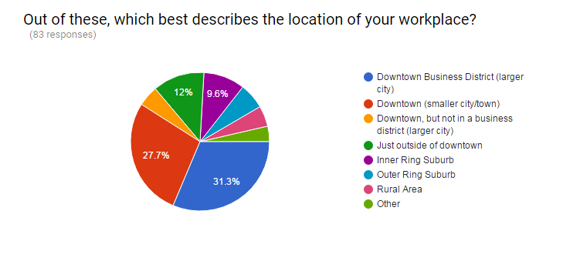

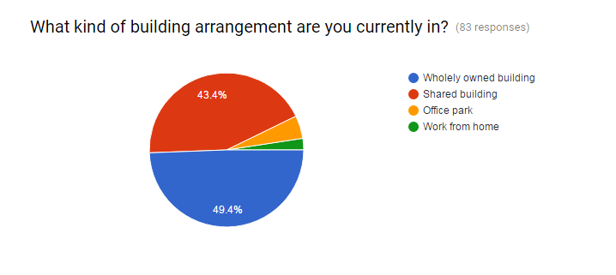

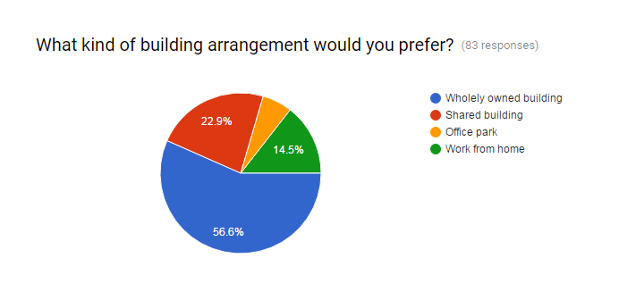

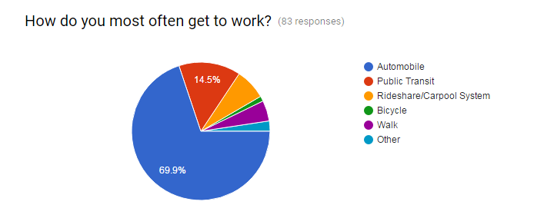

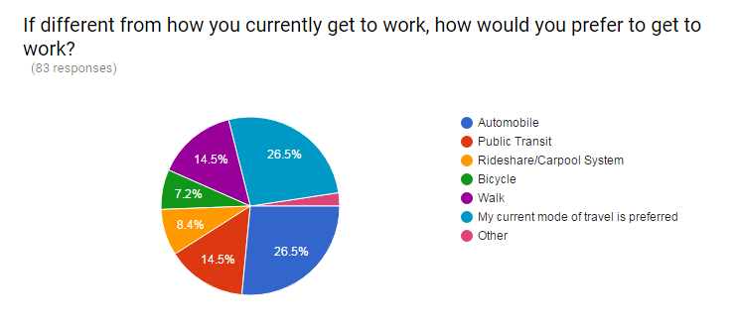

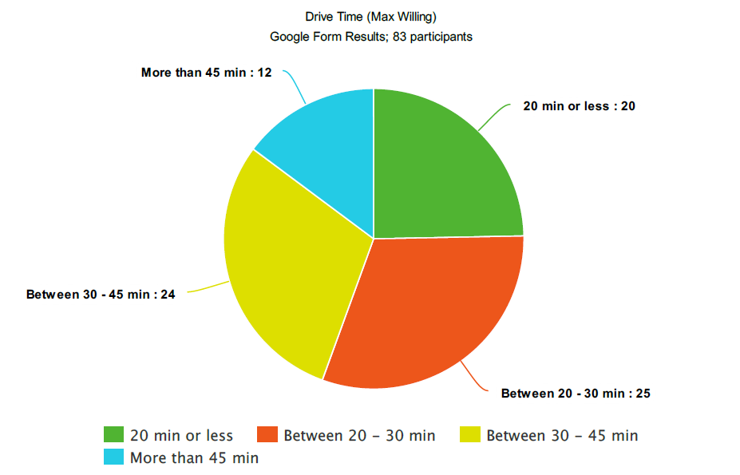

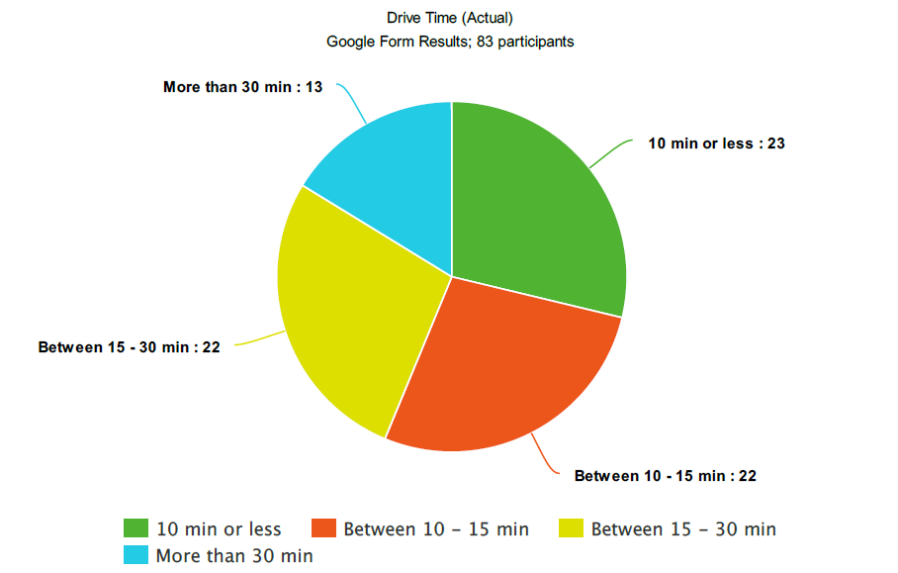

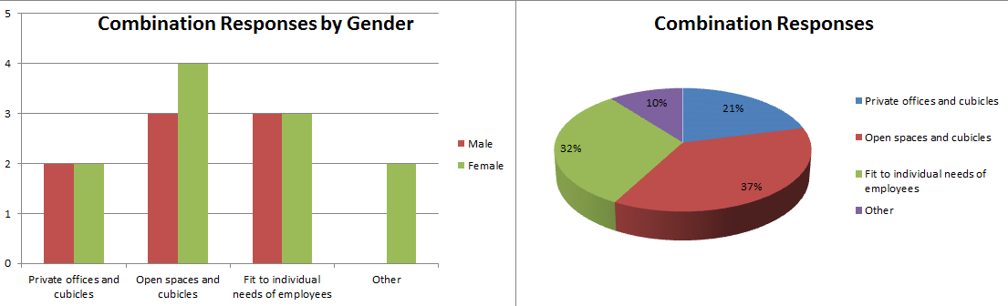

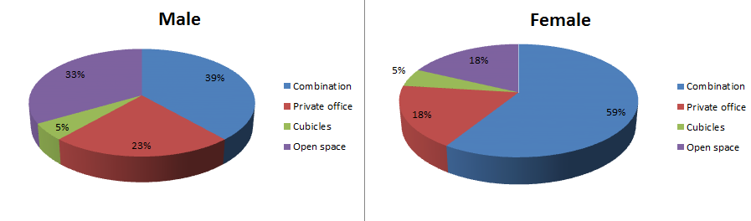

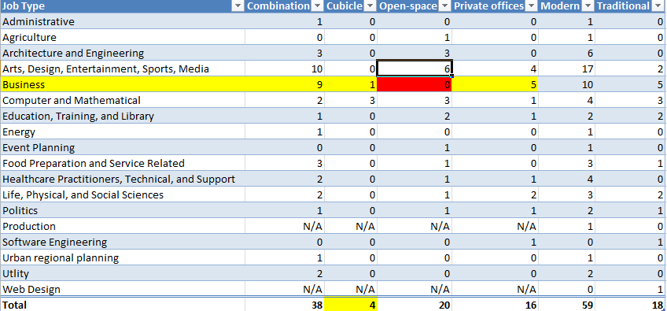

Focus Groups

